T-2HAND

User Interface Prototype Document

(Small Project)

Version <1.0>

Revision History

| **Date** | **Version** | **Description** | **Author** |
| --- | --- | --- | --- |
| 27/11/2024 | 1.0 | Complete version of the document | Trần Đan Huy |
|  |  |  |  |
|  |  |  |  |
|  |  |  |  |

Table of Contents

**1 Introduction 4**

1.1 Purpose 4

1.2 Scope 4

1.3 Definition, Acronyms and Abbreviations 4

1.4 References 4

1.5 Overview 4

**2 Figma Prototype 4**

2.1 Prototype Link 4

2.2 About Figma 5

2.3 Technical Notes 5

**3. Guests 5**

3.1 Guests page 5

3.1.1 Brief Description 5

3.1.2 Header and Slogan with Banner Slider 6

3.1.3 Most Search Items 6

3.1.4 Recently Posted 7

3.1.5 Sign In 7

3.1.6 About T-2Hands 8

3.1.7 Footer 8

3.2 Sign Up Page 9

3.3 Login Page 10

3.3.1 Login 10

3.3.2 Choose Role Page 11

3.3.3 Password Recovery Page 11

**4. Buyer 12**

4.1 Buyer Page 12

4.1.1 Header and Slogan with Banner Slider 12

4.1.2 Most Search Items 13

4.1.3 Recently Searched 14

4.1.4 About T-2Hands 15

4.1.5 Footer 15

4.2 Buyer profile page (Home customer profile Page) 19

4.2.1 Header and footer 19

4.2.2 Customer Profile 19

4.2.3 Products List 20

4.2.4 Feedback seller 21

4.2.6 Preview Page 23

4.2.7 Add to cart 25

4.2.8 Payment Page 26

4.2.9 Edit profile 28

4.2.10 Chat with seller 29

4.2.11 Get support 30

**5. Seller 30**

5.1 Seller page 30

5.1.1 Brief Description 30

5.1.2 Header and Slogan with Banner Slider 31

5.1.3 Help 33

5.1.4 Most Search Items 34

5.1.5 Your recently Posted 35

5.1.6 See What Other Are Buying 36

5.1.7 About T-2Hands 36

5.1.8 Footer 36

5.2 Seller Profile Page 36

5.2.1 Header and footer 36

5.2.2 Seller profile 37

5.2.3 Product List 38

5.3 Edit Profile Page 39

5.4 Upload Product Page 40

5.5 Product Detail Page 41

**6. Admin 42**

6.1 Admin Page 42

6.1.1 Header 42

6.1.2 Statistics 43

6.1.3 Today’s Posts 43

6.1.4 Unapproved Products 44

6.1.5 Report 45

6.1.6 Footer 45

6.2 Today’s Posts Page 46

6.3 Unapproved Products Page 47

6.4 Report Page 48

6.5 Approve Item Page 49

6.6 Users List Page 50

# 

# 

# 

# 

# 1 Introduction

## 1.1 Purpose

The objective of this User Interface Prototype Document is to define, analyze, and convey the visual and interactive components of the user interface for the T-2Hands website application. This document acts as a blueprint for developers, designers, and stakeholders, enabling them to comprehend the intended user experience and maintain a cohesive design throughout the development lifecycle.

## 1.2 Scope

This User Interface Prototype Document pertains to the T-2Hands website application, which is being developed by Group 08 - BabyX. It focuses on the design aspects and illustrates how each layout integrates seamlessly within the T-2Hands website application.

## 1.3 Definition, Acronyms and Abbreviations

| Item | Object | Description |
| --- | --- | --- |
| 1 | T-2Hands | T-2Hands is a shopping website application specifically designed as part of this project. |
| 2 | Figma | Figma is a collaborative web-based application for interface design, offering additional offline functionality through its desktop applications for macOS and Windows. |

## 1.4 References

Slides provided by Mr. Phạm Hoàng Hải, Mr. Trần Duy Hoàng, and Mr. Ngô Ngọc Đăng Khoa in the Course of Introduction to Software Engineering.

## 1.5 Overview

The User Interface Prototype Document includes the following details:

* **Figma Prototype**: Outlines the organization of the User Interface on Figma.
* **Guest**: Specifies the interface and pages designed for guests who initially access the platform.
* **Buyer**: Illustrates the user interface and screen designs for a Buyer on the platform.
* **Seller:** Depicts the visual experience of a Seller interacting with the platform.
* **Admin: :** Outlines the steps and guidelines for administrators to effectively work within their controlled workspace.

# 2 Figma Prototype

## 2.1 Prototype Link

You can view the Figma prototype for our Suki Event Management Platform by following this link: <https://www.figma.com/design/aNTklvvLfOPUvi8eos8s4P/Untitled?node-id=48-584&node-type=frame&t=48z57S2zpeiyk0u5-0>

## 2.2 About Figma

Figma is a widely used platform for creating stunning User Interface designs, which is why we have chosen it for our project. Its powerful design tools and robust prototyping features make Figma an excellent choice for designing user interfaces.

## 2.3 Technical Notes

In the prototype link, we have two different flows:

* **Guests, Buyers, and Sellers:** The primary user journey involves a Guest transitioning to a registered User, who can then assume the role of either a Buyer or a Seller. Each role offers specialized functionalities tailored to their respective objectives, which will be elaborated upon in subsequent sections of this document.
* **Administrators:** The administrative interface is designed for administrators to perform tasks such as user bans, product approvals, report reviews, and statistical analysis. This interface is restricted to authorized administrators and is not visible to general Users or Guests.

For an overview of how the T-2Hands website application works, please kindly use the Guests, Buyers, and Sellers flow. The default screen is flexible with the screen of the device that uses our website, for the best experience of using the prototype, so we advise against changing it. However, when implementing the real User Interface, the resolution may seek changes.

By combining the bold contrast of Prussian Blue and Dark Orange with the classic elegance of black and white, we aim to create a visually striking but aesthetically pleasing theme.

The following section will illustrate page and layout designs for each user role within our product. We will delve into the individual components of each design, explaining their function and how they connect to other pages.

# 3. Guests

## 3.1 Guests page

### 3.1.1 Brief Description

The **Guest Page** serves as the primary entry point for new visitors to our website. This introductory page aims to captivate guests and spark their interest in our platform.

The page is composed of seven key elements: Header, Slogan with Banner Slider, Most Searched Items, Recently Posted, Sign In, About T-2Hands, and Footer.

### 3.1.2 Header and Slogan with Banner Slider

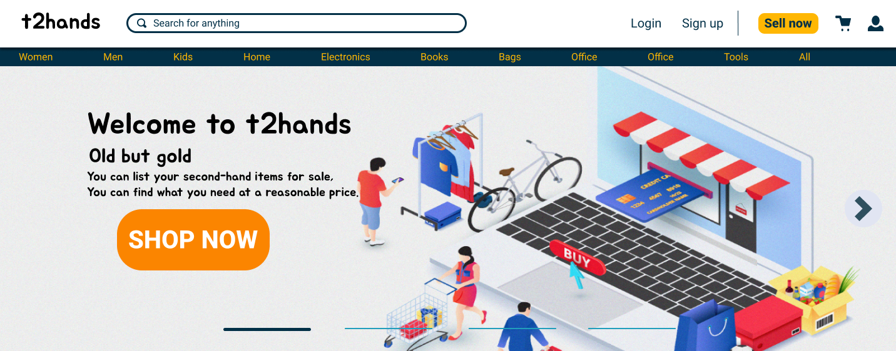

The header features our brand name, "t2hands," along with seven key elements: Search Box, Log In, Sign Up, Sell Now, Your Cart, Your Profile, and 11 Categories of Items. When any of these are clicked, users are redirected to the **Login Page**, as we are currently on the **Home (or Guest) Page**. Below the header, we display a welcoming message: “Welcome to t2hands,” followed by the slogan: “Old but gold” and a more detailed description:

“You can list your second-hand items for sale.

You can find what you need at a reasonable price.”

These lines aim to engage visitors and highlight the platform's main purpose. Additionally, a banner slider behind the slogan creates a playful feel. The **Shop Now** button directs users to the **Login Page**. As you scroll down the page, the header remains fixed at the top, ensuring it’s always visible.

### 3.1.3 Most Search Items

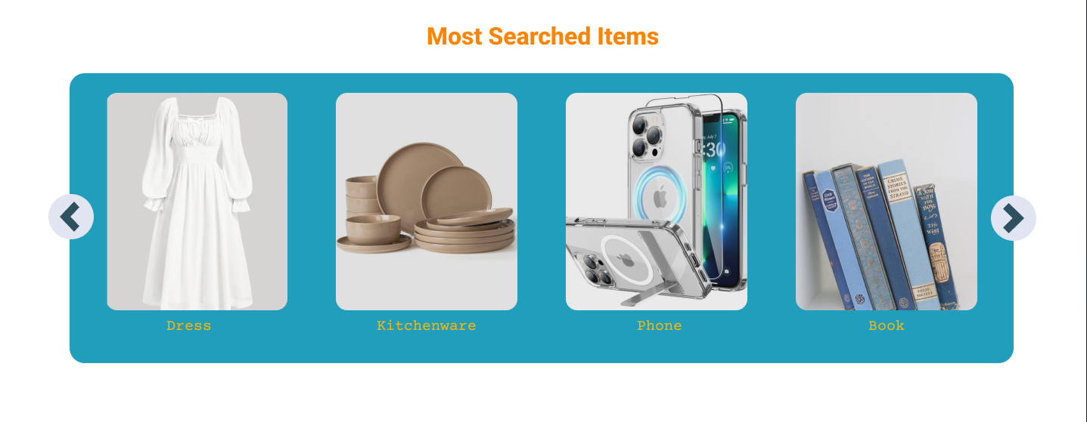

The **Most Searched Items** section indicates that this section is focused on items that are frequently searched for on the website(such as Dress, Kitchenware, Phone, …), making it easy for users to discover popular products. The surf format allows for a visually appealing presentation of these items, encouraging users to browse and explore different categories. Users can quickly click on which they like then the web navigates them to these items in this type without searching for them.

### 3.1.4 Recently Posted

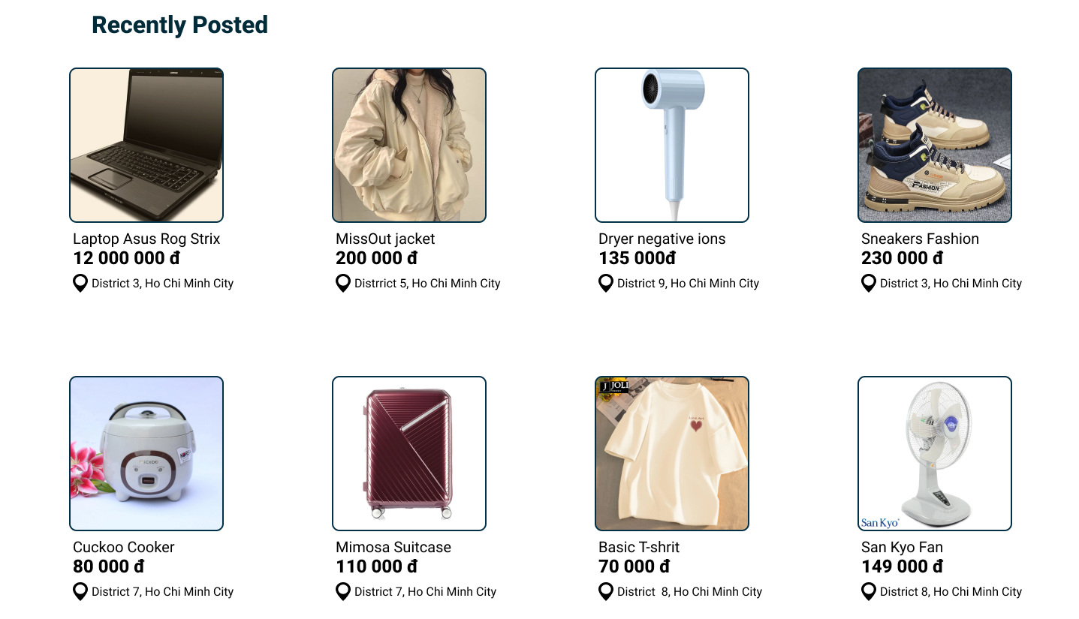

The **Recently Posted** section highlights the latest items added to the website, allowing users to discover the newest products available. This section displays a grid of product listings, each featuring an image, name, price, and location. By showcasing the most recent additions, the website encourages users to explore the latest trends and find items that pique their interest. When the user moves the cursor on a specific item, the **Preview** button will appear below each item and when clicking on it, the user is directed to a **Preview Page** where they can view more details about the product, such as additional images, a detailed description, and seller information.

### 3.1.5 Sign In



The banner displays a call to action for users to sign in to their accounts. It promises personalized recommendations, a feature that requires user data and preferences to function effectively. The "Sign in" button provides a direct link to the **Login Page**, while the "New customer? Start here!" text encourages new users to create an account **Sign Up Page.**

### 3.1.6 About T-2Hands

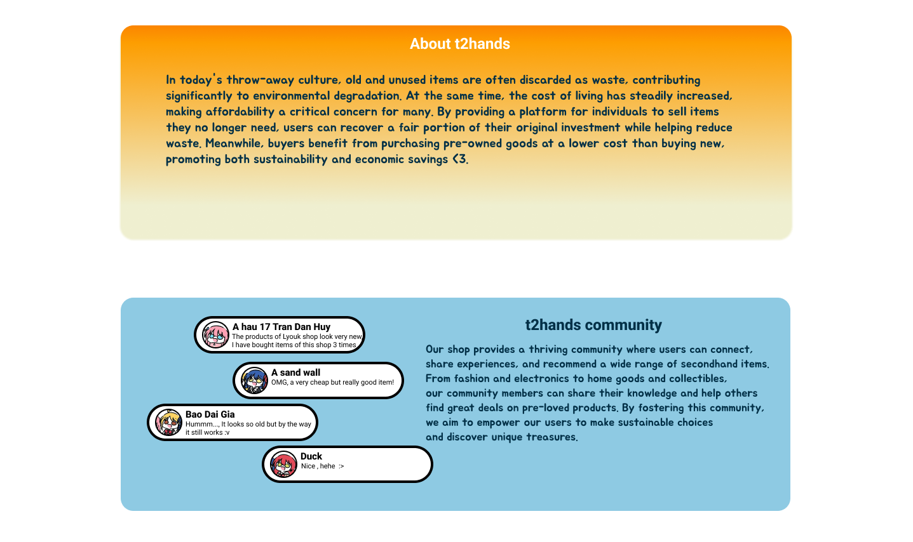

The **About t2hands** section provides an overview of the platform's mission and values. It highlights the environmental and economic benefits of buying and selling second-hand goods. The section emphasizes how t2hands helps reduce waste, promote sustainability, and save money for both buyers and sellers.

The **t2hands community** section showcases the platform's vibrant community of users who share experiences, recommendations, and knowledge about secondhand items. It emphasizes the community's role in empowering users to make sustainable choices and discover unique treasures.

### 3.1.7 Footer

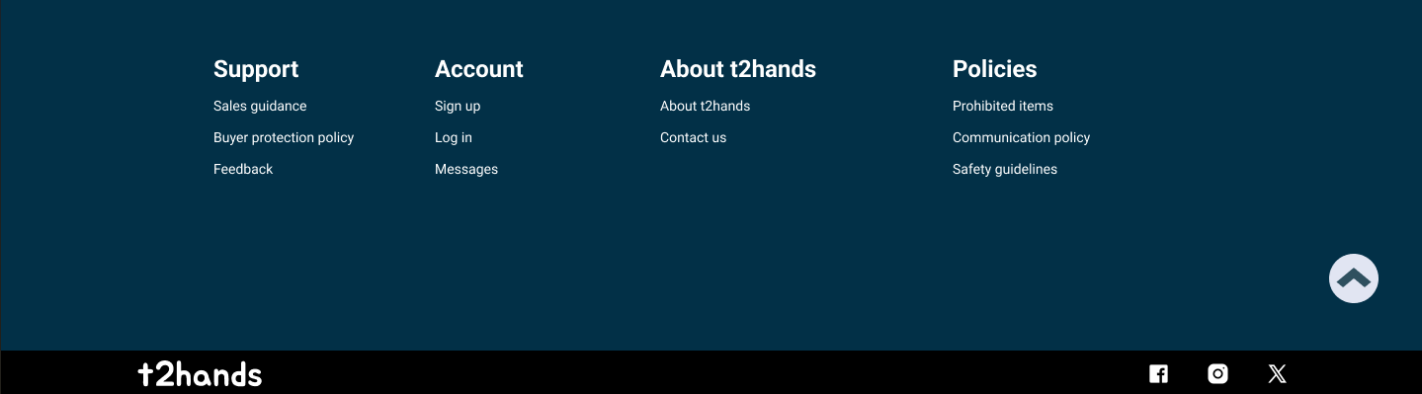

The footer section of the website provides essential information and links for users. It is divided into four main sections:

Support: This section offers resources and assistance to users, including information on sales guidance, buyer protection policies, feedback.

Account: This section provides links to user account management features, such as sign-up and login, as well as message access.

About t2hands: This section contains information about the company, including its mission, values, and contact information.

Policies: This section outlines the platform's policies, including prohibited items, communication guidelines, and safety measures.

Additionally, the footer includes:

Social Media Links: Links to t2hands' social media profiles (Facebook, Instagram, and Twitter).

Back to Top Button: A convenient button that allows users to quickly scroll back to the top of the page.

As a guest, if you click to any section of the **Footer,** you will be redirected to the **Login Page** .

## 3.2 Sign Up Page

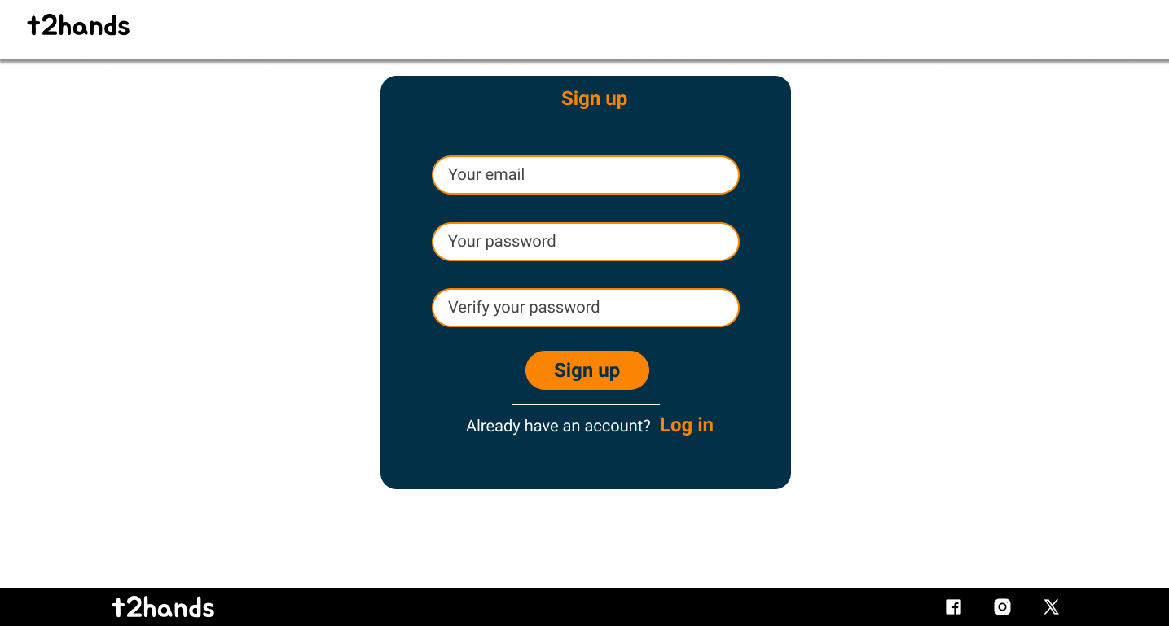

The **Sign Up Page** allows guests to create a new account on our platform. The required fields are Email, Password, and Confirm Password. Once the information is filled out, users must check a box to confirm they are creating an account. Afterward, clicking **Sign Up** will complete the account creation process.

If any required information is missing, an error message will prompt the guest to provide the missing details.

For those who already have an account, simply click **Log In** at the bottom right corner to be redirected to the **Login Page**.

## 3.3 Login Page

### 3.3.1 Login

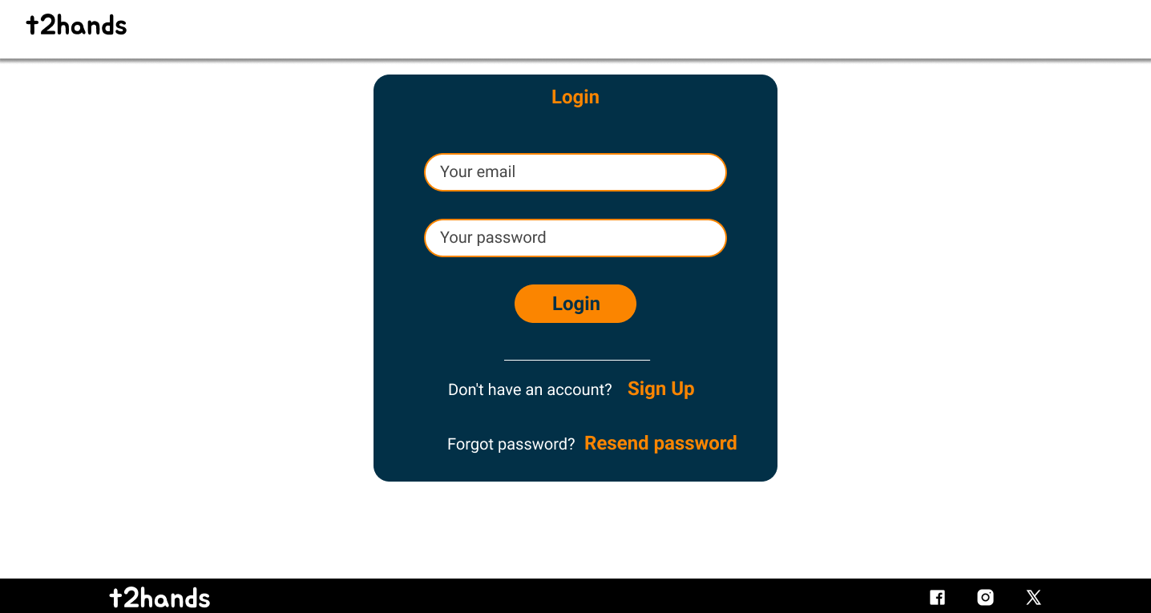

The **Login Page** allows users with an existing account to access their profile by entering their Email and Password. Once the details are filled in and the **Login** button is clicked, the user will be redirected to the **Choose Role Page**.

If you don't have an account, you can click **Sign Up** to go to the **Sign Up Page** and create a new account.

If you’ve forgotten your password, click **Resend password?** to be directed to the **Password Recovery Page**, where you will be sent your password.

### 3.3.2 Choose Role Page

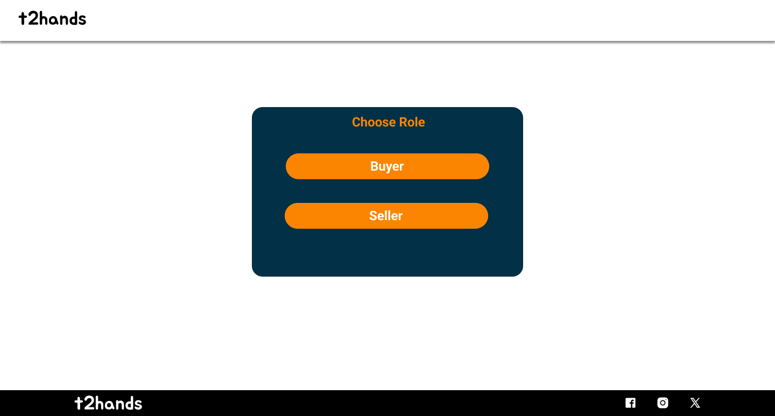

The **Choose Role Page** represents two options with two roles: Buyer and Seller. If you click on the **Buyer** button, you will be redirected to the **HomePage Buyer**, otherwise with the **Seller** button, the website will navigate you to the **HomePage Seller**.

### 3.3.3 Password Recovery Page

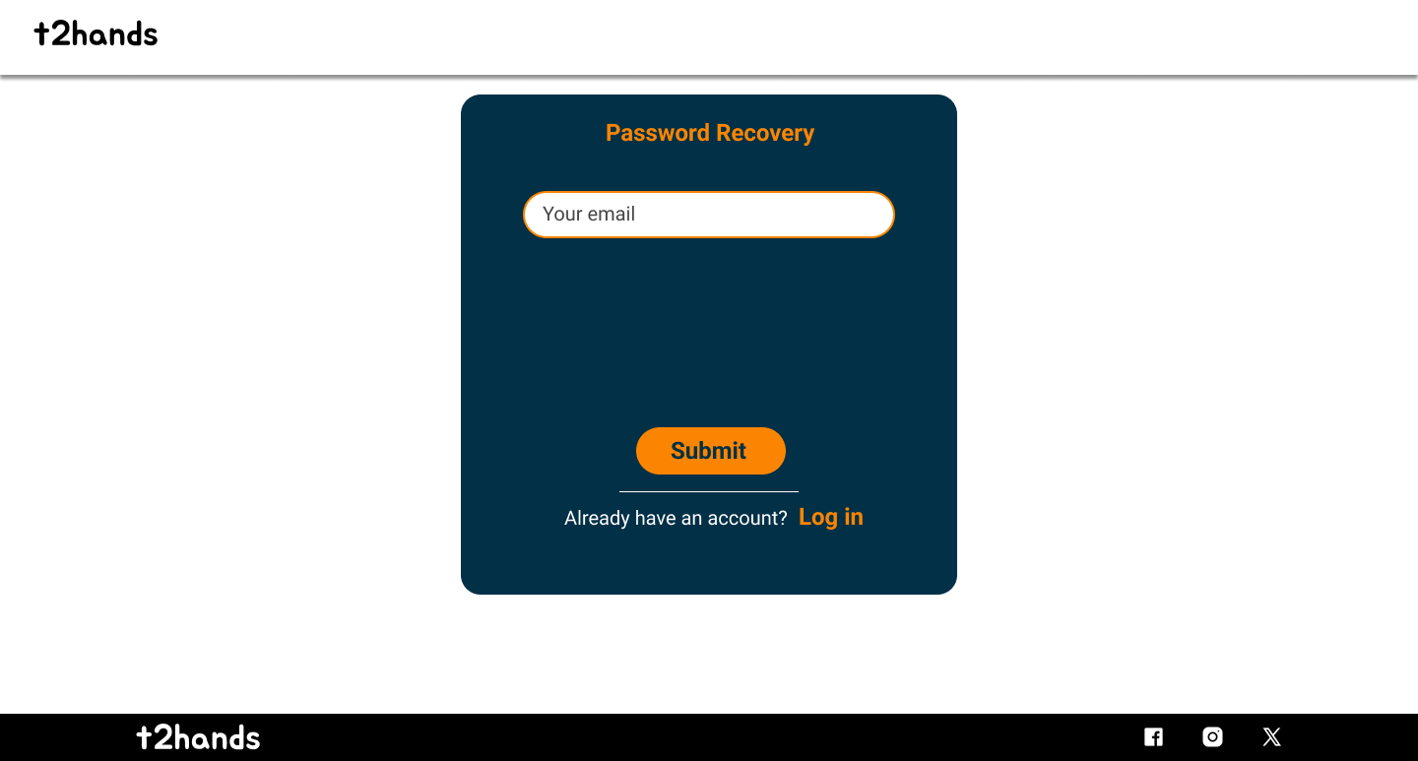

The **Password Recovery Page** prompts users to enter the email address associated with their account. After submitting the email, click **Submit** to receive a password reset link in your email inbox. Once the request is processed, you will be redirected back to the **Login Page**. While this method is not fully secure, it is our current solution. If you accidentally navigate to this page, you can click **Log In** to return to the **Login Page**.

# 4. Buyer

## 4.1 Buyer Page

### 4.1.1 Header and Slogan with Banner Slider

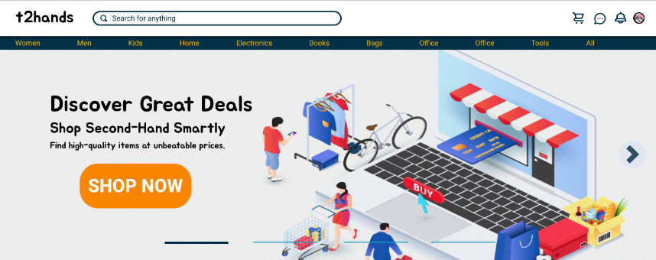

The header features our brand name, "t2hands," along with seven key elements: Search Box, Your Cart, Chat, Notification, Your Profile, and 11 Categories of Items. Below the header, we display a welcoming message: “Discover Great Deals,” followed by the slogan: “Shop Second-Hand Smartly” and a more detailed description:

“Find high-quality items at unbeatable prices”

This section is designed to captivate visitors and emphasize the platform's core purpose. Additionally, features like **Your Cart** allow users to review their shopping cart,while the chat function allows interaction between buyers and sellers with each other. A **Notifications** button ensures you stay updated with relevant information during your time on T-2Hands. By clicking on your avatar, you access your **Profile**, where you can select your role, update your information, or log out of your account. As you scroll down, the header remains fixed at the top of the page, ensuring easy navigation and constant accessibility.

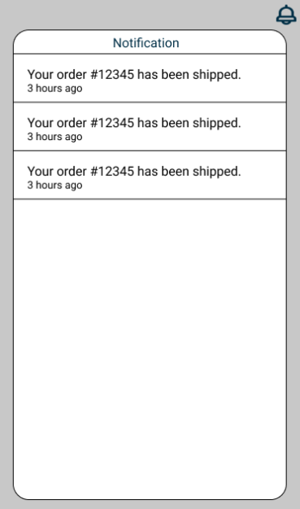

### 4.1.2 Most Search Items

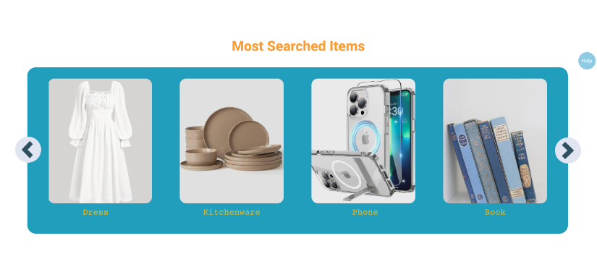

The **"Most Searched Items"** section highlights products that are frequently searched on the website, such as dresses, kitchenware, phones, and more. This feature makes it convenient for users to explore trending products effortlessly. With its visually engaging layout, the section invites users to browse and explore various categories with ease. Simply click on a product you like, and the website will redirect you to its details without the need for a manual search. Additionally, a **Help** button is available, allowing users to chat with an admin for instant support.

### 4.1.3 Recently Searched

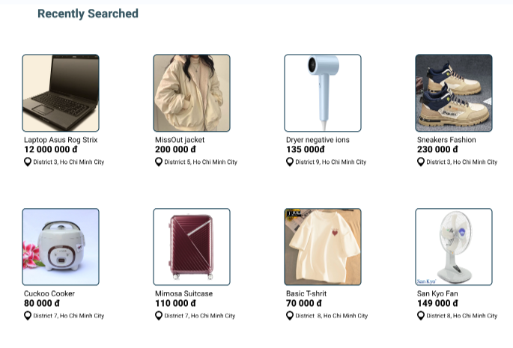

**Recently Searched** is a feature that allows users to easily access products they have recently searched for. These products are saved and displayed in a list or thumbnail format, enabling users to quickly revisit the details without having to search again. The section also features a grid of product listings, each showcasing an image, name, price, and location, highlighting the most recent additions. This encourages users to explore the latest trends and discover items that catch their interest.When users click on a specific item, a **See Preview** button appears. Upon clicking it, they are redirected to the **Preview** page, where they can view additional images, detailed descriptions, and seller information. This feature provides convenience, saves time, and enhances the overall online shopping experience.

### 4.1.4 About T-2Hands



The "About t2hands" section provides an overview of the platform's mission and values. It highlights the environmental and economic benefits of buying and selling second-hand goods. The section emphasizes how t2hands helps reduce waste, promote sustainability, and save money for both buyers and sellers.

The "t2hands community" section showcases the platform's vibrant community of users who share experiences, recommendations, and knowledge about secondhand items. It emphasizes the community's role in empowering users to make sustainable choices and discover unique treasures.

### 4.1.5 Footer



The footer section of the website provides essential information and links for users. It is divided into four main sections:

**Support:** This section provides users with resources and assistance, including guidance on sales, buyer protection policies, and feedback channels. Clicking on any section under "Support" will redirect users to the "Support Page" for more detailed information.

**Account:** This section offers links for managing user accounts, such as signing up, logging in, and accessing messages. Selecting **Sign Up, Log In. or Messages** will navigate users to their respective pages.

**About t2hands:** This section shares details about the company, including its mission and values. Clicking this section takes users to the **About T-2Hands** above or redirects them to our Facebook page for direct contact if needed.

**Policies:** This section outlines the platform's rules and guidelines, including prohibited items, communication standards, and safety measures. Clicking on any policy will navigate users to the "Policies" page for comprehensive details.

Additionally, the footer includes:

Social Media Links: Links to t2hands social media profiles (Facebook, Instagram, and Twitter).

Back to Top Button: A convenient button that allows users to quickly scroll back to the top of the page.

4.1.5.1 Support Page

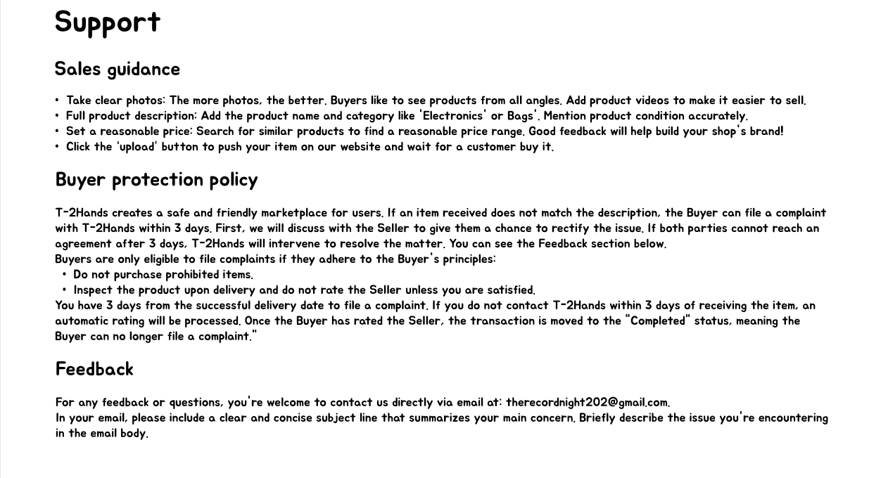

The following sections in the **Support** page provide key information and guidance to help users maximize their experience on T-2Hands, ensuring smooth transactions, protection, and effective communication.

**Sales Guidance**

This section provides tips for improving your sales performance, focusing on creating visually appealing and detailed product listings, setting competitive prices, and encouraging buyer feedback to build a strong reputation.

**Buyer Protection Policy**

This section explains the platform's buyer protection measures, including how to file complaints if products do not match their descriptions, the timeline for resolving disputes, and the importance of following buyer responsibilities. It also outlines what happens once a transaction is completed.

**Feedback**

This section guides users on how to contact T-2Hands for support, emphasizing clear and concise communication via email to ensure effective assistance.

4.1.5.2 Policies Page

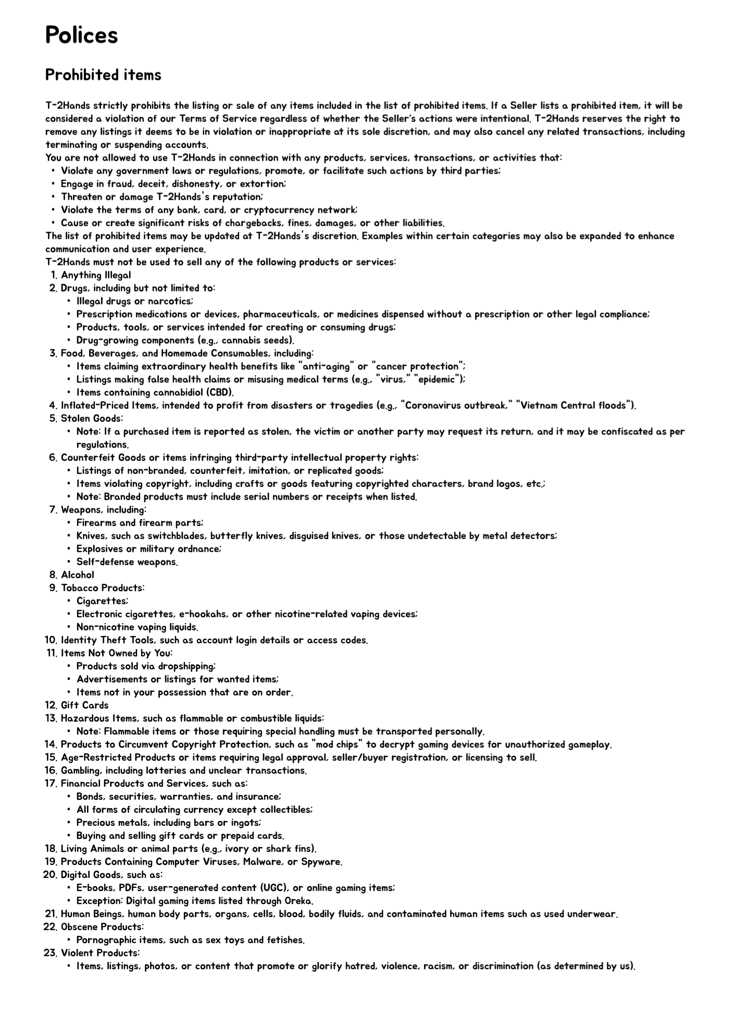

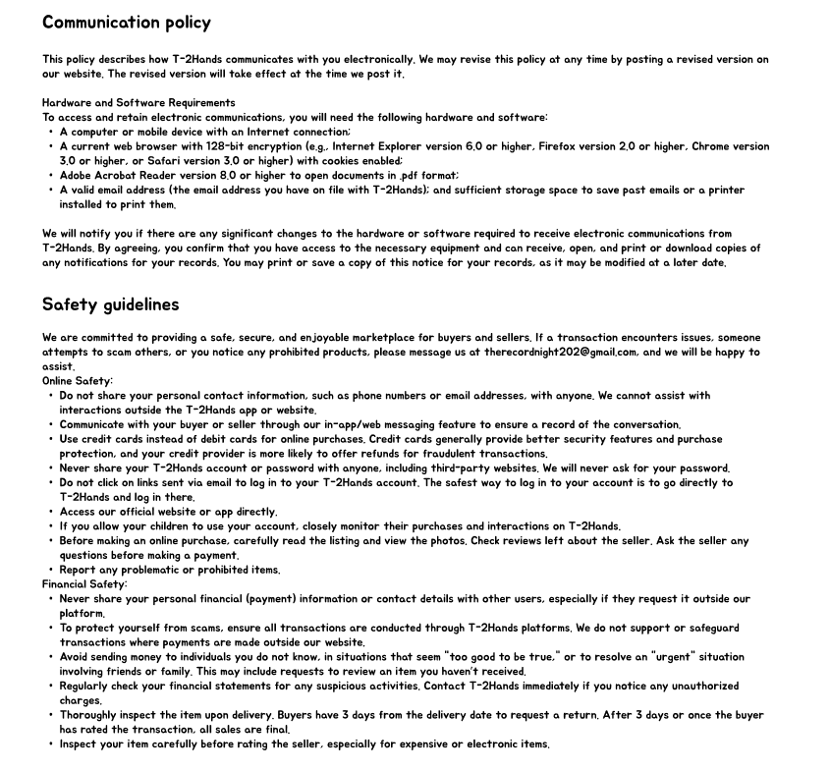

The following sections of **Policies** page outline essential rules, guidelines, and best practices to ensure a safe, fair, and respectful experience for all users on T-2Hands platform.

**Prohibited Items**

A detailed list of items that are not allowed for sale on the platform. It includes categories such as illegal substances, hazardous materials, counterfeit goods, and specific restricted items (e.g., alcohol, firearms, and certain electronics). The section emphasizes compliance with laws and outlines penalties for violations.

**Communication Policy**

Guidelines for appropriate communication between users. It includes rules against harassment, sharing personal information, and misuse of messaging features. Users are encouraged to communicate respectfully and adhere to platform standards.

**Safety Guidelines**

Tips for ensuring safe transactions and interactions. The section covers advice on personal safety during exchanges, secure payments, and safeguarding personal information. Users are urged to follow best practices to avoid scams or risky situations.

## 4.2 Buyer profile page (Home customer profile Page)

### 4.2.1 Header and footer

Header and footer are similar to those in the buyer page.

### 4.2.2 Customer Profile



In the **Customer Profile** page, each user can view their basic information, including their avatar and the username displayed on the T-2Hands platform. This username is solely for display purposes and is not used for logging in. Additionally, the profile also shows the month and year the customer joined T-2Hands, providing a snapshot of their journey on the platform.

### 4.2.3 Products List

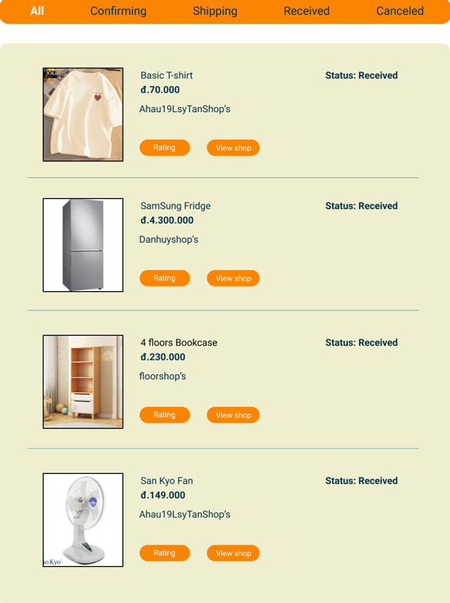

On the **Customer Profile** page, T-2Hands is designed with a user-friendly interface to present product information in the most intuitive way, ensuring convenience and ease of use. The platform also provides a **navigation bar** that allows users to effortlessly track the status of their orders. Each product is clearly labeled with its current status, such as *confirming*, *shipping*, *received*, or *canceled*, so users can stay updated on the progress of their purchases.

For every product, detailed information is available, including the product name, image, price, and the shop selling it. You can view more products by scrolling up, and additional products will appear below. Users can directly rate the seller by clicking the **Rating** button, but only when the product is in the **Received** status. Additionally, they can explore more about the shop and its other products by clicking the **View Shop** button. This feature provides an overview of the seller's credibility and reviews, helping users make informed decisions.

### 4.2.4 Feedback seller

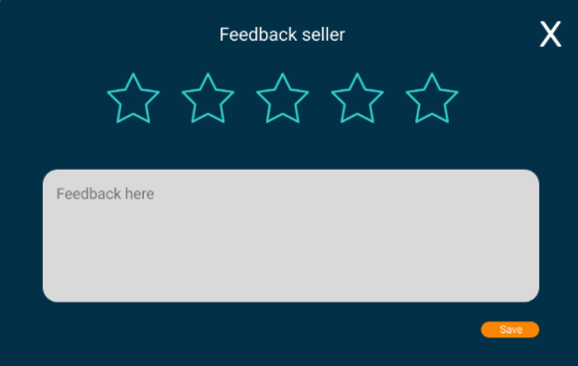

On the **Customer Profile** page, customers can rate sellers directly by clicking the **Rating** button in the product list. Here, users can evaluate the quality of the products they purchased by rating the seller using a star system. Higher star ratings reflect better product quality and indicate whether the seller is trustworthy.

In addition to star ratings, customers can provide detailed feedback in the **Feedback Here** section, where they can describe their product experience and share their thoughts. Once the rating and feedback are completed, clicking the **Save** button ensures that the review is submitted. All submitted reviews will be publicly displayed on the seller's page, offering transparency and helping others make informed decisions

4.2.5 Seller profile

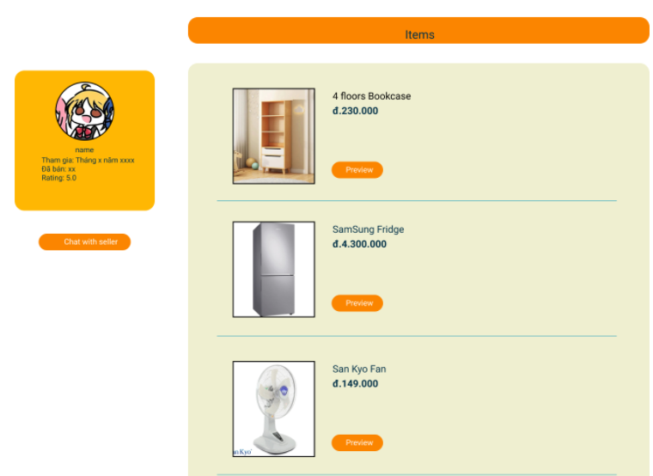

This is the interface customers see after clicking the **View Shop** button in the **Products List** section of the Customer Profile page. Customers are presented with detailed and visually organized information about the seller, including their username, avatar, the month and year they joined T-2Hands, the total number of products sold, and the seller's rating. The rating reflects the seller's reliability and the quality of the products they offer. You can view more products by scrolling up, and additional products will appear below.

The **Seller Profile** page also displays basic details about the products the seller has listed for sale, such as the product avatar, name, price, and a **Preview** button. By clicking **Preview**, customers can view comprehensive details about the selected product, enhancing their shopping experience.

When you click the **Chat with Seller** button, a messaging dialog will open directly on the current page; it will not navigate to a separate page. Since you are already in the seller's profile, clicking the button will automatically start a chat with that seller without the need to search for their name.

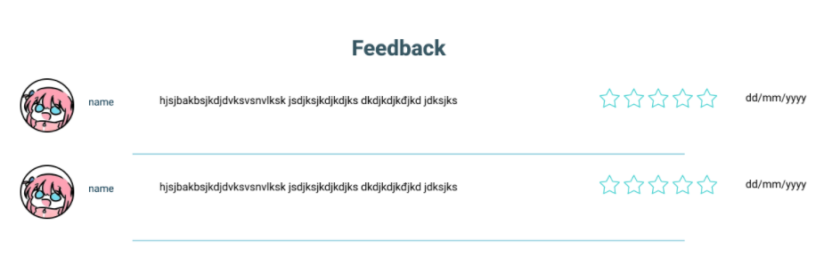

Additionally, the **Seller Profile** page publicly displays all user reviews. Each review includes key details such as the customer's name, avatar, a description of their purchasing experience, the rating score, and the date the review was submitted. This transparency helps other users assess the seller’s credibility and product quality based on real customer feedback.

### 4.2.6 Preview Page

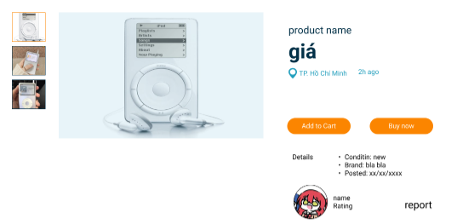

After clicking the Preview button on the Product card, users can view detailed information about the product they are interested in. This includes a series of product images, the product name, price, seller’s address, and the time the product listing was posted. Additionally, important details such as the product's condition, brand, and posting date are displayed.

The **Preview** page also shows essential seller information, including their avatar, username, rating, and customer feedback they have received. Customers are provided with two options for the product: **Add to Cart** or **Buy Now**, ensuring a seamless shopping experience.

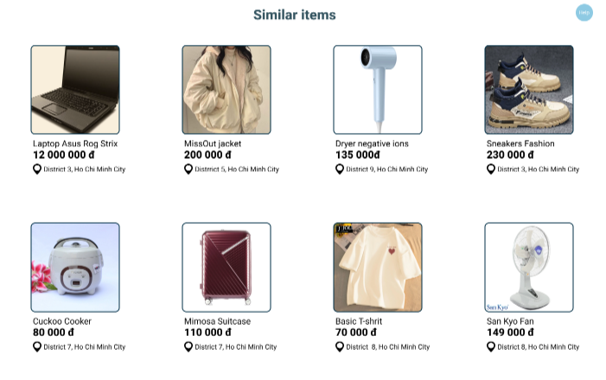

Additionally, the **Preview** page features a **Similar Items** section, showcasing products that are similar to the one the customer is interested in. These items are displayed with basic information to help customers quickly assess their options. Details include the product name, image, price, and seller’s location, making it easier for customers to explore and compare alternatives.

### 4.2.7 Add to cart

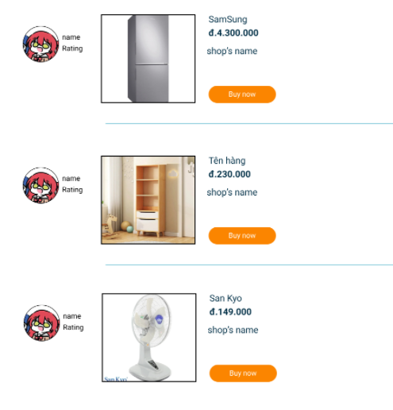

This is the page displayed when a customer clicks on the cart icon in the header, confirming that the product has been successfully added to their cart. The cart lists all the products the customer has added, with each product displayed alongside its basic details, including the product name, image, price, and the shop name.

Additionally, the cart provides seller information, such as the seller's name, avatar, and rating, reflecting their reliability. Each product entry also includes a **Buy Now** button, enabling customers to proceed directly to purchase the items they need and love with ease.

### 4.2.8 Payment Page

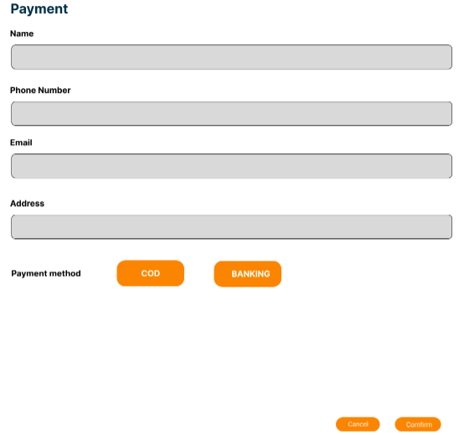

This is the **Checkout** page, which appears when the customer clicks the **Buy Now** button in their cart or on the **Preview** page. This page allows customers to complete their payment for the product they wish to purchase.

Customers are required to provide personal information for payment, such as their name, phone number, email, delivery address, and preferred payment method. They can choose between two payment options: a quick bank transfer or cash on delivery.

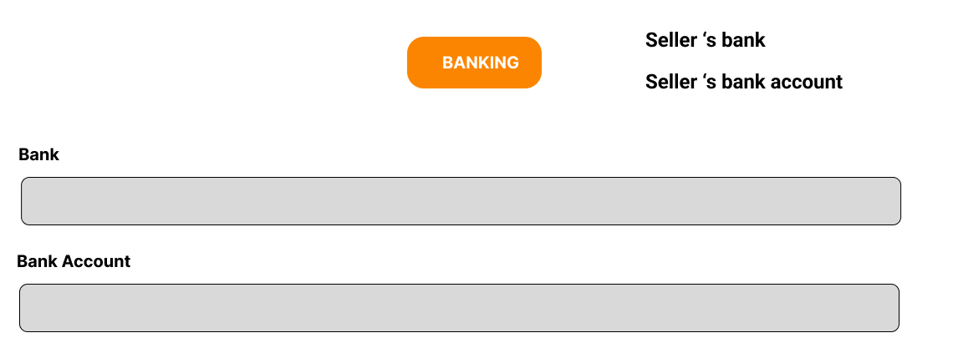

After filling in all personal information, the customer selects a payment method. If you choose the **Cash on Delivery (COD)** option, click the **COD** button and then press **Confirm** to finalize the purchase. If you select the **Bank Transfer** method, click the **Bank** button, and the seller's bank details and account number will be displayed. At this point, you need to enter your own bank name and account number to proceed with the transfer. Similarly, after completing the selection, press **Confirm** to finalize the payment. If you decide not to proceed with the purchase, click the **Cancel** button to cancel the transaction, and all entered information will be discarded.

### 4.2.9 Edit profile

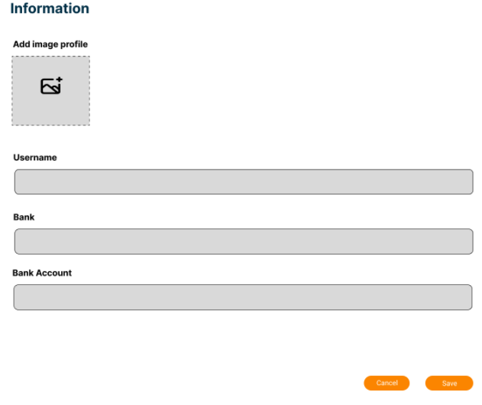

Each customer can edit their profile through a dedicated page, which appears when they click on their avatar in the header or select **Edit Profile** on the **Customer Profile** page. This page allows customers to update their personal information while using the T-2Hands platform.

The information that can be updated includes the customer's profile picture, username, bank name, and the corresponding account number. Once the customer has filled out the necessary details, they can click **Save** to update and store the information in the system. If the customer decides not to make any changes, they can click **Cancel** to exit the page, and any updates will be discarded.

### 4.2.10 Chat with seller

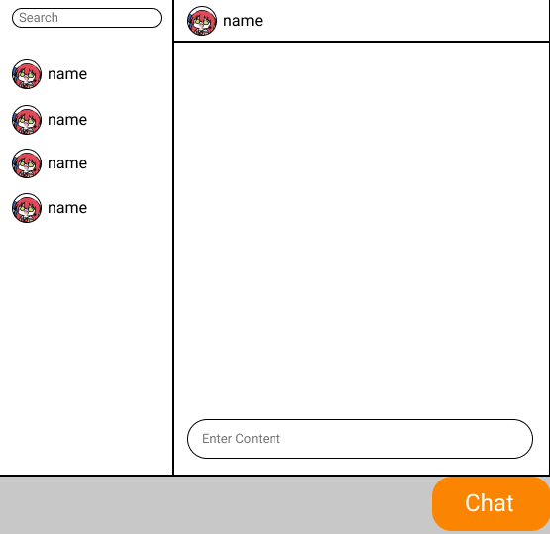

This page is designed for customers to have direct conversations with sellers about product details or any questions they may have. Customers can communicate directly with sellers by entering their messages in the "Enter Comment" box and pressing Enter to send them. Each chat session is limited to one seller at a time, allowing customers to address their specific concerns with the selected seller.

On the left side of the page, there is a list of sellers that the customer can chat with. To start a conversation, the customer simply clicks on the corresponding seller's name or uses the Search bar to find a seller by name.

This messaging page appears when customers click on the Message icon in the header of the Home Customer Page or the Message icon in the Customer Profile. When the customer clicks the chat button or the message icon in the header, a dialog box will appear directly on the current page. This chat box does not redirect to a separate page.

### 4.2.11 Get support

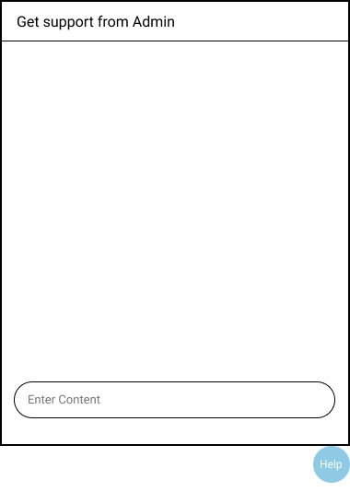

This page is designed to provide support and assistance to customers when they encounter issues. The main purpose of the support channel is to address all customer inquiries and help resolve any problems they may face. Customers can enter their questions or requests for assistance in the "Enter Content" box and press Enter to send the message. The admin will read the messages and respond as quickly as possible to assist the customers.

This support page appears when customers click the Help button on the Home Customer Page or the Help button in the Customer Profile. When you click the Help button, a dialog box will appear directly on the current page you are viewing, rather than opening in a separate page.

# 5. Seller

## 5.1 Seller page

### 5.1.1 Brief Description

The Seller Page is a hub for listing and managing second-hand items. It empowers users to connect with buyers and turn preloved goods into new opportunities in a sustainable marketplace.

The page includes eight key elements: Header, Slogan with Banner Slider, Help, Most Searched Items, Your Recently Posted, See What Others Are Buying, About T-2Hands, and Footer.

### 5.1.2 Header and Slogan with Banner Slider

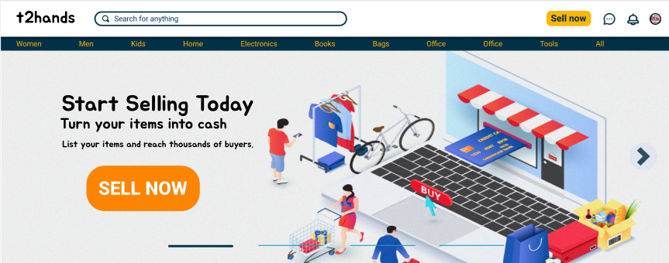

The header features our brand name, "t2hands," along with six key elements: Search Box, Sell Now, Chat, Notification, Your Profile, and 11 Categories of Items.

Search Box: Users can input the name of the item they want to search in here.

Sell Now: When this button is clicked, users will be redirected to the **Upload Product Page** to post their products on the platform.

Chat: By hitting on the Dialogue icon, sellers can open a chat box on this page to chat with buyers. Sellers can communicate directly with buyers by entering their message in the "Enter Comment" box and pressing Enter to send the message. Each message session is limited to one seller at a time, allowing sellers to address their specific inquiries with the chosen buyer. On the left side of the box, there is a list of buyers that the seller can chat with. To start a conversation, the seller simply clicks on the corresponding buyer's name, or they can use the Search bar to find a buyer by name. To close the dropdown, users can simply click the icon one more time.

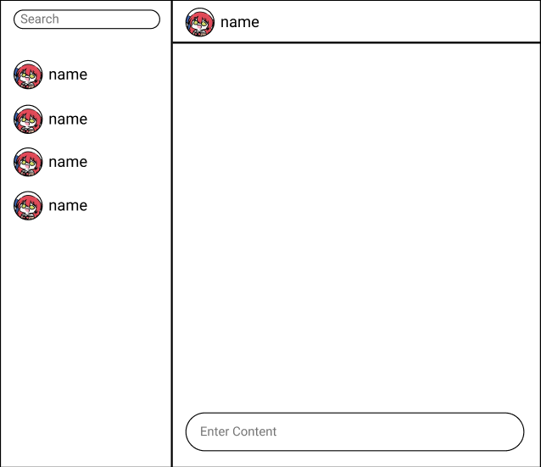

Notification: Users can click on the *Bell* icon to check their notifications if there are any, such as when a product is purchased by a buyer or a product is approved by an admin. The notifications are displayed in a dropdown which appears when the icon is clicked. To close the dropdown, users can simply click the icon one more time.

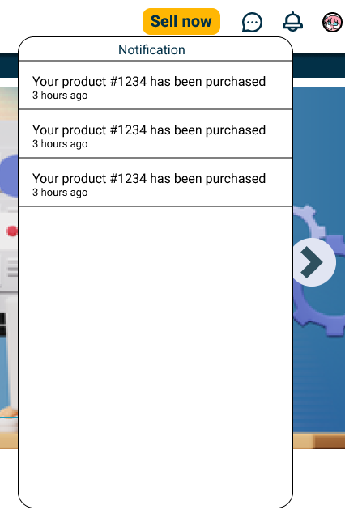

Your Profile: By clicking on your avatar, a dropdown will appear and there are three buttons in it. To close the dropdown, users can simply click the avatar one more time.

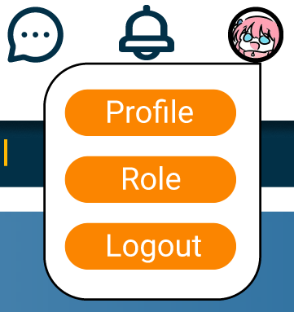

* Profile: Users can access their Profile Page by clicking on this button.
* Role: Users can re-choose their roles by clicking on this button and the website will redirect them to the Choose Role Page.
* Logout: Users can log out by hitting this button and they will be redirected to the Guest Page.

Below the header, we display a welcoming message: “Start Selling Today,” followed by the slogan: “Turn your items into cash” and a more detailed description: “List your items and reach thousands of buyers”.

As you scroll down the page, the header remains fixed at the top, ensuring it’s always visible.

### 5.1.3 Help

This button always stays in a position on the right side of the page regardless of whether the users scroll up or down.

By clicking on this button, users can open a box chat to require support from the admins.



Users can easily get help from the admins by entering their requirements in this chat box. Then they can close it by clicking again on the button.

### 5.1.4 Most Search Items



This section is similar to the “Most Search Items” section in the Guest Page.

Users can click on the two arrow buttons on either side of the section to browse more items.

### 5.1.5 Your recently Posted

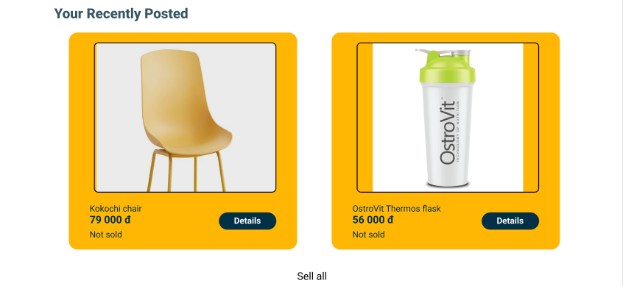

This section provides sellers a quick view to check the status of their latest items without heading to the **Profile Page**. This section displays a sequence of product listings, each featuring an image, name, price, and status.

Sellers can promptly review their items’ details by clicking on the *Details* button, then the website will switch to the **Product Detail Page**.

When the *See all* link is clicked, users are redirected to their **Profile Page** to review all products uploaded by themselves.

### 5.1.6 See What Other Are Buying

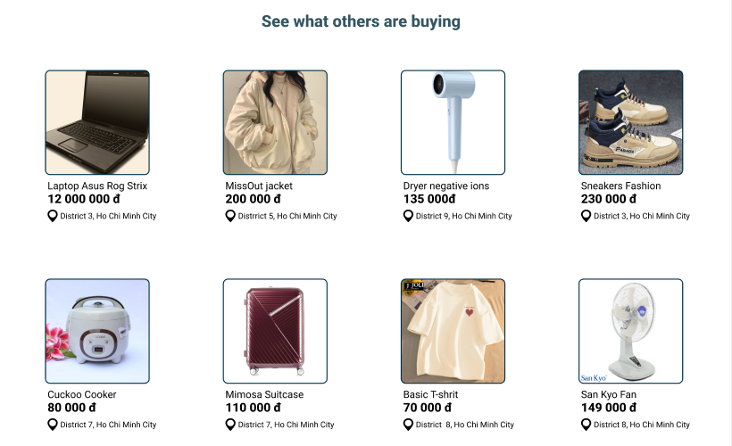

The "See What Others Are Buying" section highlights the latest items added to the website by other sellers, allowing users to survey the newest products available on the market. This section displays a grid of product listings, each featuring an image, name, price, and location. When the user moves the cursor on a specific item, the **Preview** button will appear below each item and when clicking on it, the user is directed to a **Preview Page** where they can view more details about the product, such as additional images, a detailed description, and seller information.

### 5.1.7 About T-2Hands

This section is similar to the one in **Buyer Page**.

### 5.1.8 Footer

This section is similar to the one in **Buyer Page**.

## 5.2 Seller Profile Page

### 5.2.1 Header and footer

Header and footer are similar to those in the **Seller Page.**

### 5.2.2 Seller profile

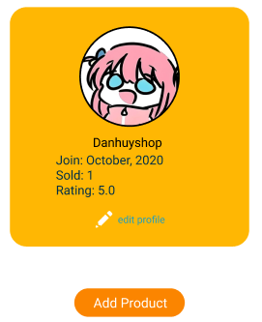

In this section, each user can view their basic information, including their avatar and the username displayed on the T-2Hands platform. This username is solely for display purposes and is not used for logging in. Additionally, the profile also shows the month and year the user joined T-2Hands, the number of items they have sold, and the rating customers rated them, providing a snapshot of their journey on the platform. Users can update their information (avatar, username) by clicking on the *edit profile* button and then they will be redirected to the **Edit Profile Page**.

Also, sellers can navigate to the **Upload Product Page** by hitting on the *Add Product* button.

### 5.2.3 Product List

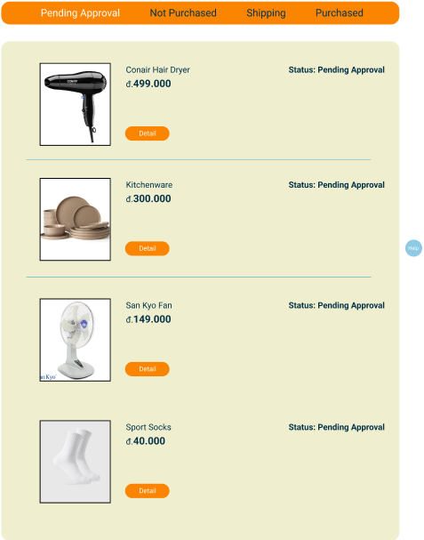

On the **Seller Profile Page**, T-2Hands is designed with a user-friendly interface to present product information in the most intuitive way, ensuring convenience and ease of use. The platform also provides a navigation bar that allows users to effortlessly track the status of their items. Each product is clearly labeled with its current status, such as pending approval, not purchased, shipping, or purchased, so users can stay updated on the progress of their purchases.

For every product, detailed information is available, including the product name, image, price, and its status.

Additionally, they can review more about the products’ details by clicking the *Detail* button. This feature provides an overview of their product in the **Product Detail Page**.

## 5.3 Edit Profile Page

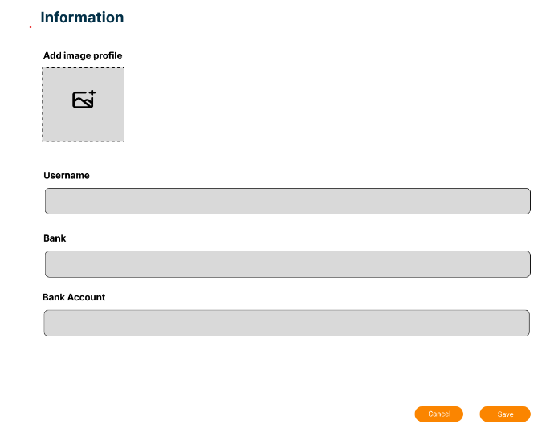

Each seller can edit their profile through a dedicated page, which appears when they select *Edit Profile* on the **Seller Profile Page**. This page allows sellers to update their personal information while using the T-2Hands platform.

The information that can be updated includes the seller's profile picture, username, bank name, and the corresponding account number. Once the seller has filled out the necessary details, they can click Save to update and store the information in the system. If the seller decides not to make any changes, they can click Cancel to exit the page, and any updates will be discarded.

## 5.4 Upload Product Page

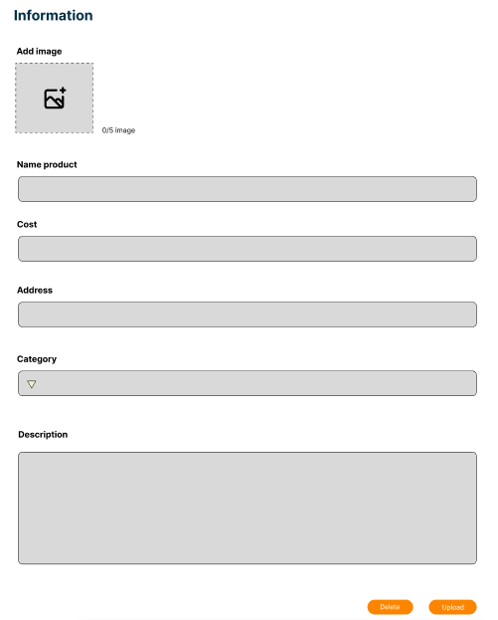

Each seller can post their product through a dedicated page, which appears when they click on the *Add Product button* on the **Seller Profile Page**. This page allows sellers to upload their product’s information while using the T-2Hands platform.

The information that can be uploaded includes the product’s image, name, cost, address, category, and a brief description. Once the seller has filled out the necessary details, he/she can click the *Upload button* to post the product on the website. If the seller decides not to upload, they can click the *Delete button* to exit the page, and any updates will be discarded.

## 5.5 Product Detail Page

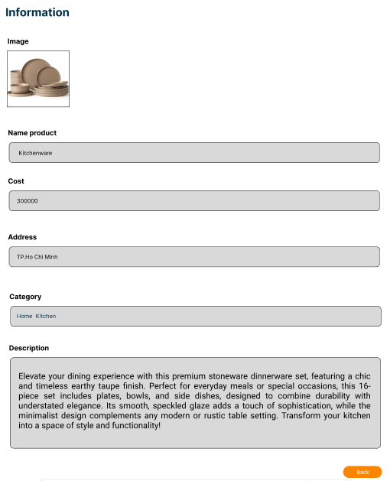

Each seller can review their product’s details through a dedicated page, which appears when they click on the *Detail button* on the Seller Profile Page. This page allows sellers to check their product’s information while using the T-2Hands platform.

The information that can be reviewed includes the product’s image, name, cost, address, category, and the brief description. Once the seller completes checking the product information, he/she can click the *Back button* to return to the **Seller Profile Page**.

# 6. Admin

## 6.1 Admin Page

### 6.1.1 Header

The header features our brand name, "t2hands," along with three key elements: Chat, Notification, Profile.

Chat: By hitting on the phone icon, admins can open a chat box which is used to give support to the users who have sent requirements for help.

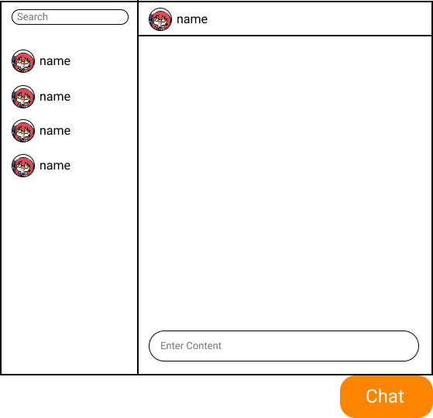

Administrators can communicate directly with users by entering their message in the "Enter Comment" bar and pressing Enter to send the message. Each message session is limited to one user at a time, allowing administrators to address their specific inquiries with the chosen user. On the left side of the box, there is a list of users that the administrator can chat with. To start a conversation, the administrator simply clicks on the corresponding user's name, or they can use the Search bar to find a user by name.

Notification: It is similar to the Notification in **Seller/Buyer Page.**

Profile: A dropdown will appear when the admin clicks on the avatar, it includes a *Logout* button, if the admin wants to log out, he/she just needs to select it.

### 6.1.2 Statistics

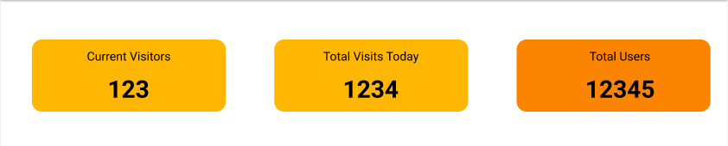

The Statistics section provides an overview of website activity, displaying three key metrics:

* Current Visitors: Shows the number of users currently browsing the site.
* Total Visits Today: Displays the total number of visits recorded for the day.
* Total Users: Indicates the cumulative number of registered users. Users can click on this section to open the **Users List Page**.

This section offers administrators a quick insight into site traffic and user engagement.

### 6.1.3 Today’s Posts

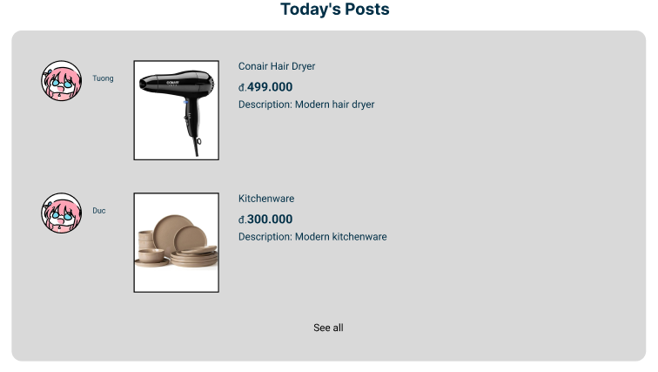

The Today's Posts section highlights newly listed items on the platform. Each post includes:

* Seller's Profile Picture & Name: Displays the avatar and name of the user who posted the item.
* Item Details: Shows the item name, price, and a brief description.

A *See all* link at the bottom allows users to view more posts at **Today’s Posts Page**, encouraging further browsing of available listings.

### 6.1.4 Unapproved Products

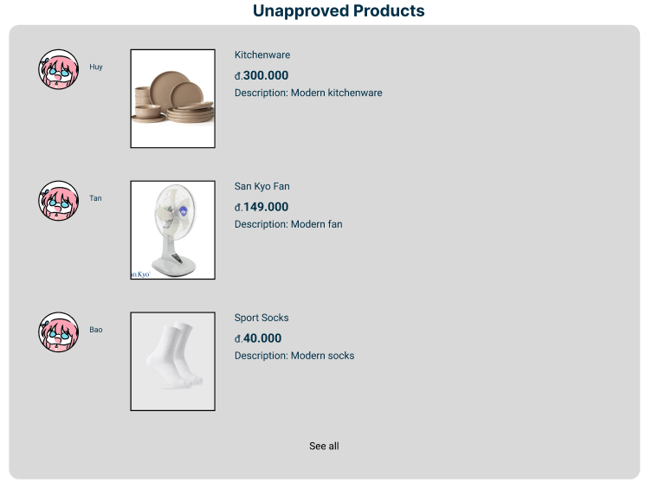

The Unapproved Products section lists items that have been submitted by users but are pending administrative approval. This ensures that only appropriate and verified products appear on the platform. Each listing includes:

* Seller's Profile Picture & Name: Identifies the user who submitted the product.
* Product Information: Displays the product name, price, and a brief description.

The administrators can hit any item to open the **Approve Item Page** to conduct approval.

The *See all* link at the bottom allows administrators to review all pending products in detail at **Unapproved Products Page**, facilitating efficient moderation.

### 6.1.5 Report

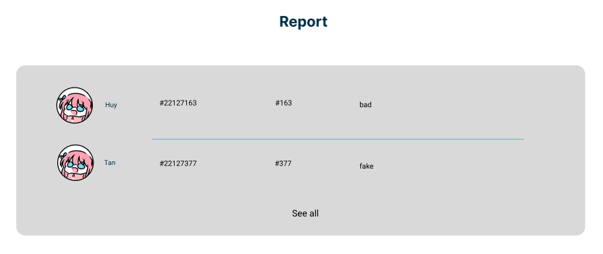

This Report section indicates the complaints of users when they have some problems with the product which is sold by a seller. Each report contains:

* Reported user’s information: Identifies the seller whose product violates T-2Hands policies, including avatar, username and user's id.
* Product: Identifies the product’s id violates T-2Hands policies.
* Content: Displays content of the complaint about that product.

The *See all* link at the bottom allows administrators to view all reports in detail at **Report Page**, facilitating efficient moderation.

### 6.1.6 Footer

This section is similar to the one in **Buyer Page**.

## 6.2 Today’s Posts Page

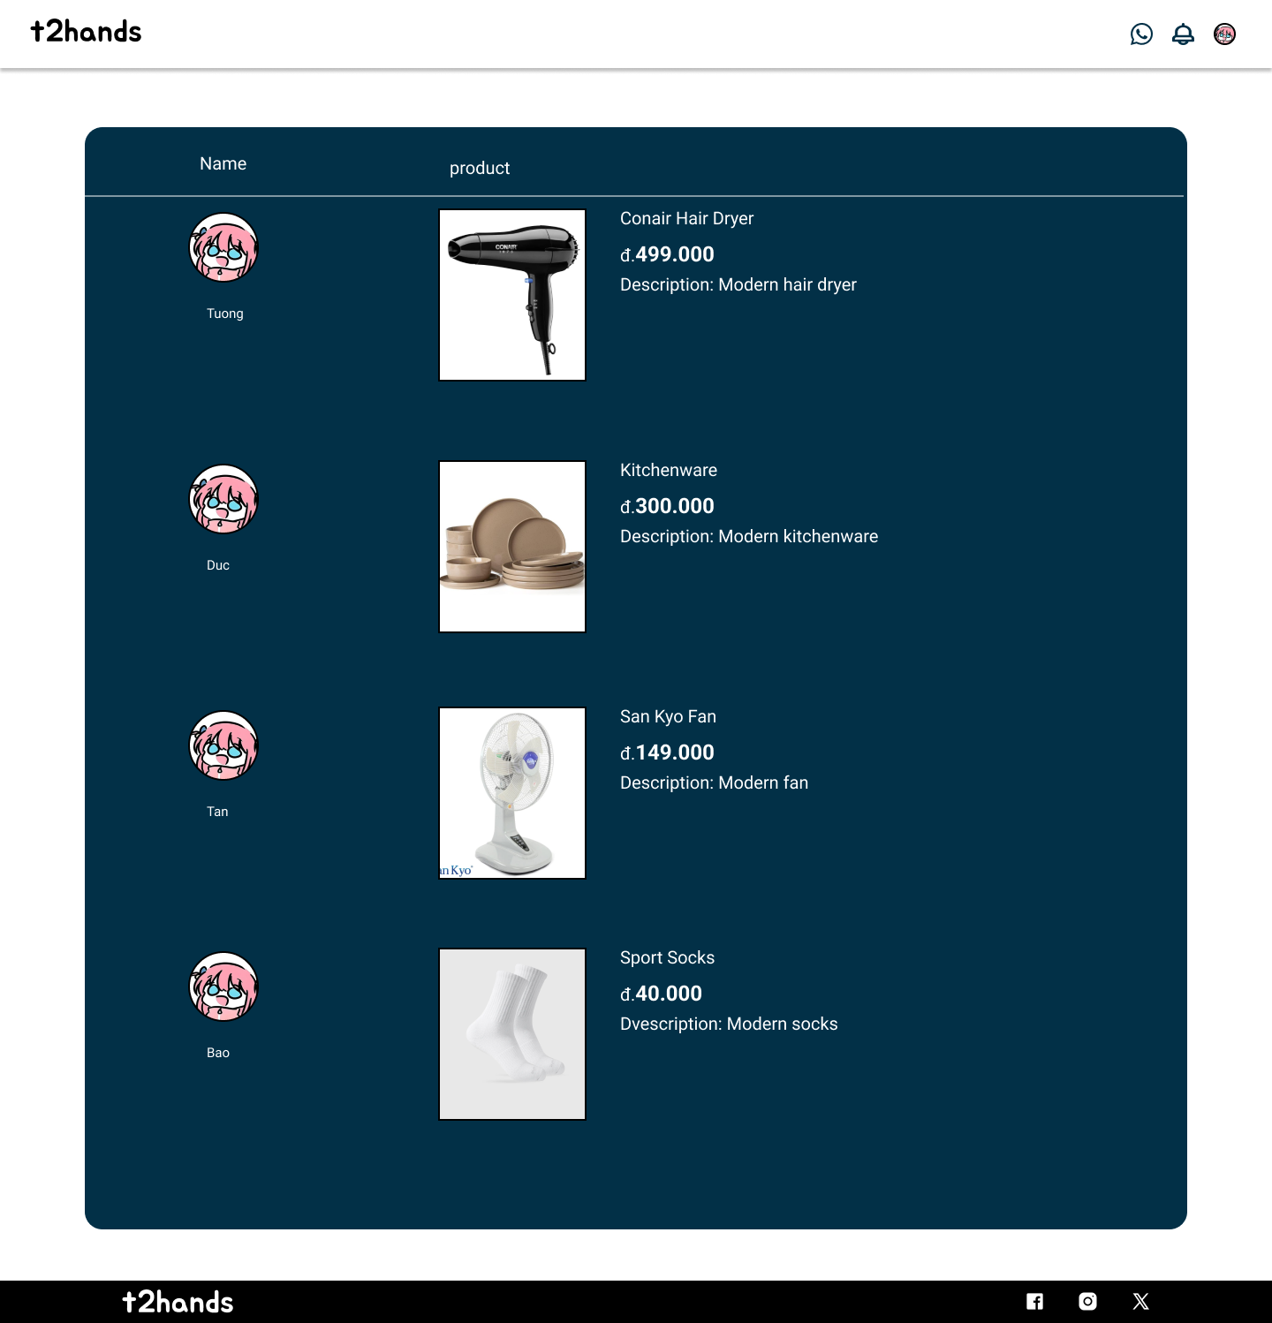

This page is the full list of the section “Today’s Posts” in the **Admin Page** when users hit the *See all* link**.** Users can scroll down to see the whole list of items.

The header is similar to the **Admin Page’s** header. Users can click on the logo to return to the **Admin Page**.

The footer includes t2hands logo and t2hands' social media links (Facebook, Instagram, and Twitter).

## 6.3 Unapproved Products Page

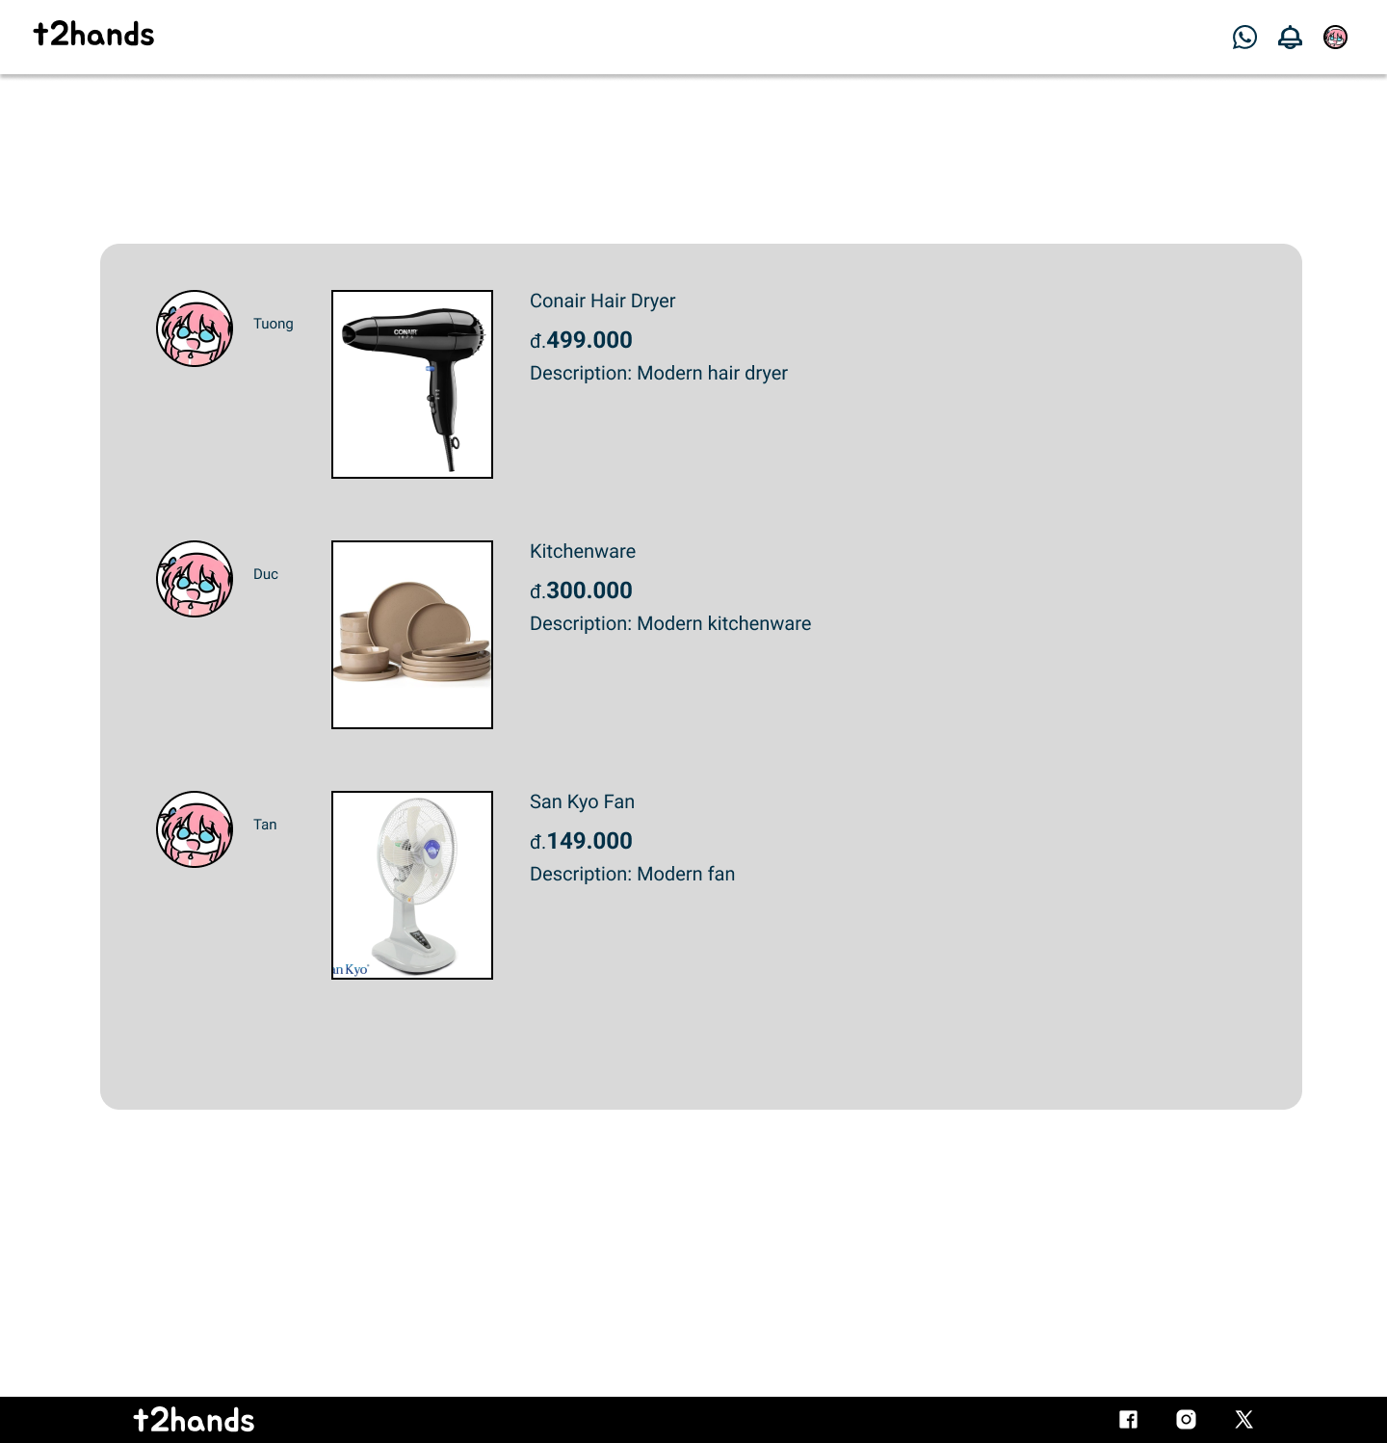

This page is the full list of the section “Unapproved Products” in the **Admin Page** when users hit the *See all* link**.** Users can scroll down to see the whole list of items.

The header is similar to the **Admin Page’s** header. Users can click on the logo to return to the **Admin Page**.

The footer includes t2hands logo and t2hands' social media links (Facebook, Instagram, and Twitter).

## 6.4 Report Page

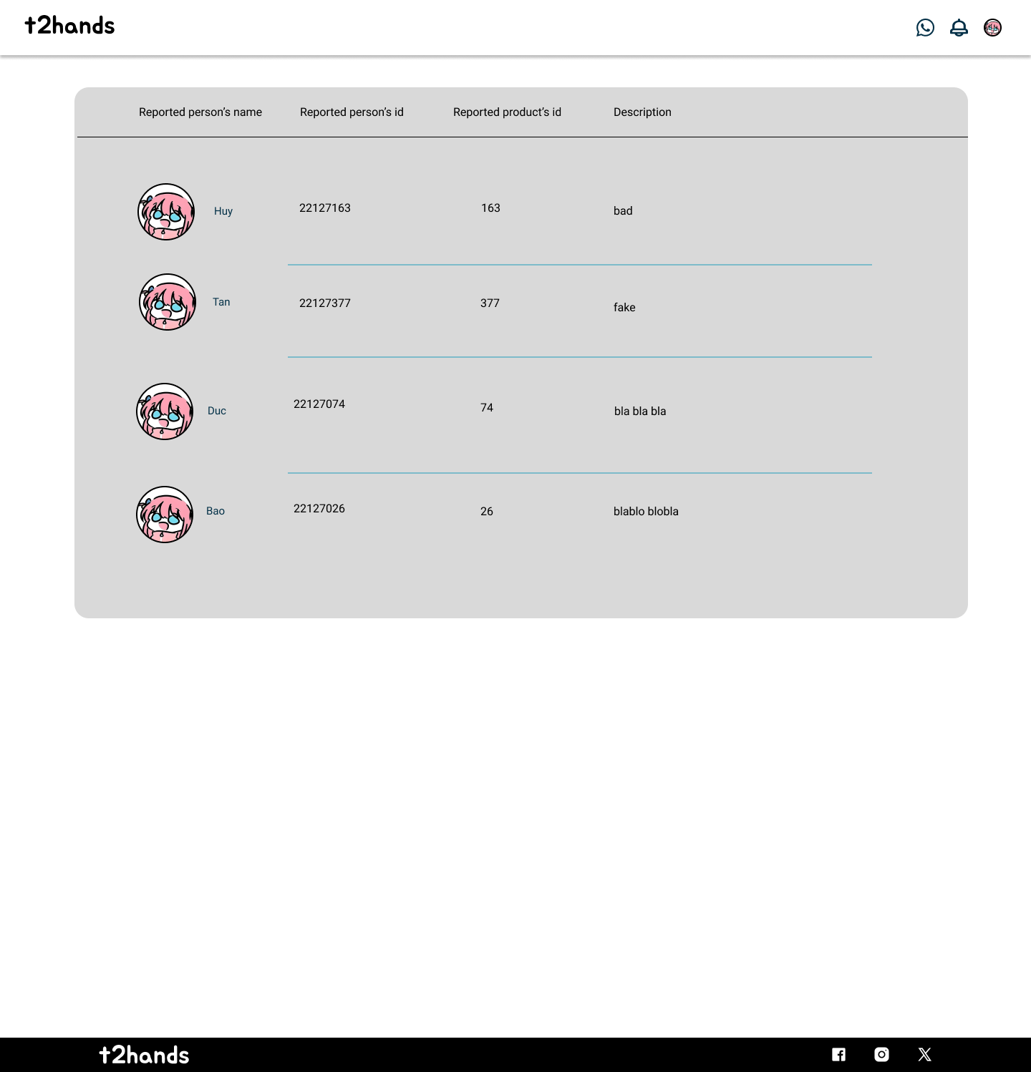

This page is the full list of the section “Report” in the **Admin Page** when users hit the *See all* link**.** Users can scroll down to see the whole list of reports. Based on those reports, administrators could decide to ban that user’s account throughthe **User List Page**. For example, when an admin finds a report about a seller who posts a fake product, he/she could use the reported product’s ID to search on the **User List Page** to locate that account and ban (delete) it.

The header is similar to the **Admin Page’s** header. Users can click on the logo to return to the **Admin Page**.

The footer includes t2hands logo and t2hands' social media links (Facebook, Instagram, and Twitter).

## 6.5 Approve Item Page

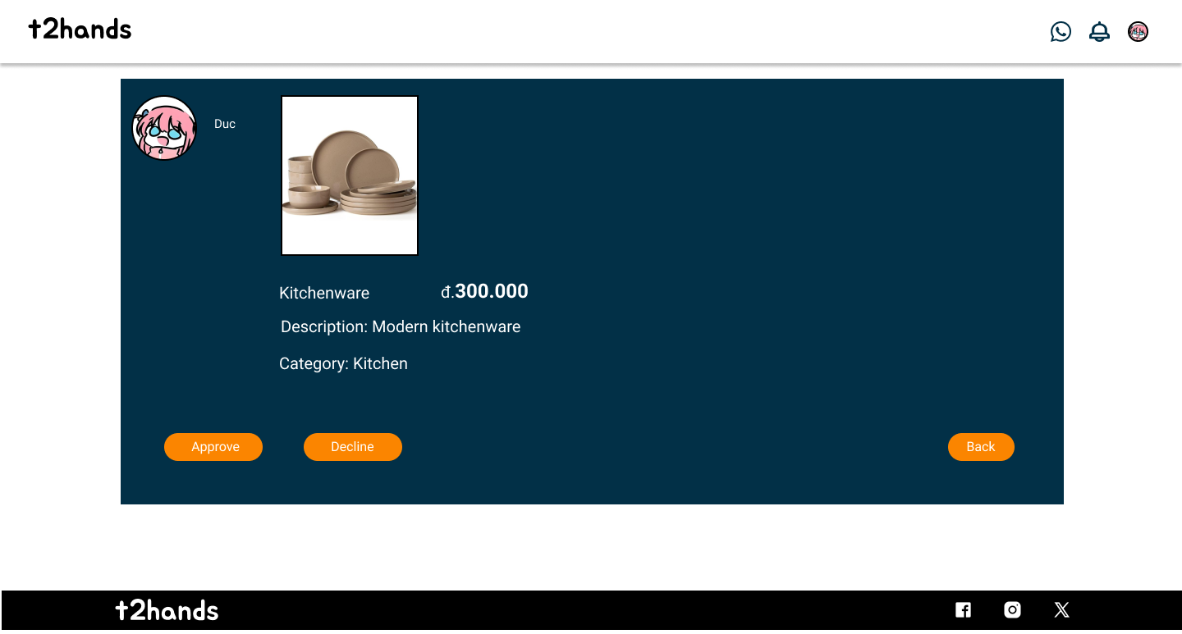

Each administrator can review sellers’ product details and decide to approve or not through a dedicated page, which appears when they click on a product in the section “Unapproved Posts” in the **Admin Page**. This page allows administrators to approve sellers’ products by clicking the *Approve* button. If the product is not satisfied with the general standard, administrators can decline it by hitting the same name button.

The information that can be reviewed includes the product’s image, name, cost, category, and the brief description.

The header is similar to the **Admin Page’s** header. Admins can click on the logo to return to the **Admin Page**. Or they can easily click the *Back* button at the right down corner to do the same activity.

The footer includes t2hands logo and t2hands' social media links (Facebook, Instagram, and Twitter).

## 6.6 Users List Page

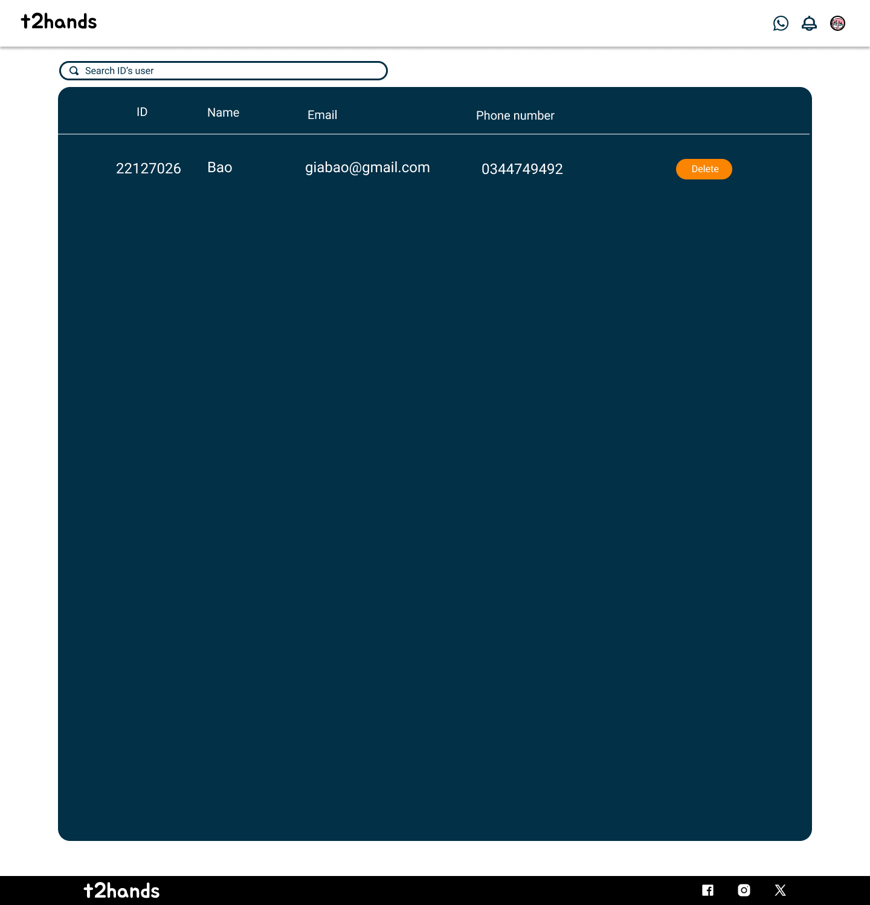

Each administrator can review users’ accounts through a dedicated page, which appears when they click on the “Total Users” in the section “Statistics” in the **Admin Page**.

This page contains a box indicating the user’s ID, name, email, and the phone number of each account. Also, there is a search bar above it which is used for administrators to find an user’s account using its ID.

This page allows administrators to delete an user account by clicking the *Delete* button on the right side of each row if that account violates community standards.

The header is similar to the **Admin Page’s** header. Users can click on the logo to return to the **Admin Page**.

The footer includes t2hands logo and t2hands' social media links (Facebook, Instagram, and Twitter).